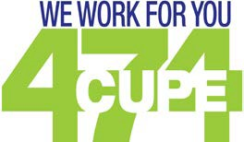Published by the Local 474 Membership
Local NEWS
Attend the General Meeting
Union Representation 780-447-5858 Monday to Friday 8:00 am to 4:30 pm
October 2017
Special Bylaw Meeting
There will be a Special Meeting to address the amendments to the CUPE 474 bylaws and the approval of the Building Society bylaws at the conclusion of the General Membership Meeting on October 14, 2017.
Dates to Remember
October 9, 2017
October 10, 2017

October 14, 2017
October 20, 2017
October 28, 2017
Thanksgiving World Mental Health Day General Meeting EPSB PD Day
Retirement Banquet

October 2017

Be a Winner!
We will be providing door prizes

President’s Message
CUPE Local 474 has a long history of being involved in Political Activism, and this year during the Municipal Election Campaign, we have been actively working with our partners at the Edmon- ton and District Labour Council as well as CUPE Alberta to promote and endorse labour friendly candidates that are running in the Municipal Elec- tion to be councilors or public school trustees.
We believe that advancing the working conditions of our membership goes beyond the work we are doing in bargaining, that it extends to electing
the civic politicians that govern our city and our schools.
CUPE Local 474 believes that every person has the right to vote for whom ever they chose, and for what ever reason they chose to vote for them. We would never tell you who to vote for. What we would tell you is which candidates we believe are the candidates that have the same or similar values that CUPE 474 have. What we would also do is encourage you to vote.
So, get out on October 16 and vote, if you can’t vote on October 16, get to an advance polling sta- tion and vote between October 4 and 13. It may sound cliche, but in Municipal Elections, every vote matters.

Custodial Leadership Preparation Program
GENERAL MEMBERSHIP MEETING 10989-124 St
October 7th Saturday at 9:00 am
CUPE Local 474 has worked with the Employer to
develope the Custodial Leadership Preparation Program. This program provides an opportunity for custodial staff to learn the skills they will need to become Head Custodians with Edmonton Public Schools. The program will in- clude six to seven full days of professional devel- opment throughout the 2017-2018 school year.
Sessions will be scheduled on designated profes- sional development days and non-instructional days. The follwowing program sessions will be:
- Building Operations
- Safety and Security 3.Community Use of Schools
- Interpersonal Skills
- Supervisionand Evaluation
- Administrative Duties
If you are interested, you must talk to your Princi- pal about particpating in the program. After that, Contact Staff Development at 780 429 8213 or go online and complete the registration form.

The deadline to apply for this program is October 11, 2017.
Inside this Edition: Page 2 - Dates to Remember Page 3 - Education
Page 5 - Member Recognition Page 6 - Retirement Party

Caring for Each Other

Gourmet fruit baskets, flowers or a card were sent over in September to the following members that were
off work for over 5 days: Deb Morin, Roger Dumais, Ruth Sana, and Olha Savchyn.

Our sympathy goes out to the following members and their families for the loss of a family member: Annelyn Bodegon, Fermin Bodegon, and Felino Dela Cruz

Municipal Election for the
City of Edmonton October 16, 2017
Do you want to Elect your Bosses?
School Trustee Elections is your opportunity to elect your bosses. School Trustee elections are usually won or lost by a handfull of votes, so every ballot counts. Voting day for your School Board Trustees and City Councilors is October 16, 2017.
If you can’t get out to vote October 16, there is an option of voting in advance, between October 4, and October 13, 2017. There are six advance
voting locations. To find your advance poll location, or any other Municpal Election information, type “Edmonton Elections” in your search window, and choose the City of Edmonton website.

Custodial Mentors
Looking for some advice? Need some support?- Call the EPSB Custodial Mentors for any questions on operations.The Mentors provide non-evaluative mentorship and coaching support to Head Custodians. This service will be provided
at no cost to schools. That means it’s free, so take advantage of this service. Contact Kristin Salahub at: kristin.salahub@epsb.ca or 780 893 9956 or Brylle Bangit at:
brylle.bangit@epsb.ca or 780 868 4574.

CUPE LOCAL 474 Endorses the Following Candidates for City Council and Public School Board Trustee

City Council:
Ward 3 Dave Loken
Ward 4 Aaron Paquette
Ward 5 Miranda Jimmy
Ward 7 Mimi Williams
Ward 8 Ben Henderson
Ward 9 Rob Agostinis
Ward 10 Vieri Berretti
Ward 11 Karen Tang

Public School Trustees:
Ward A Ahmed Knowmandic
Ward B Michelle Draper
Ward C Shelagh Dunn
Ward D Trisha Estabrooks
Ward E Sam Filice
Ward F Michael Janz
Ward G Bridget Stirling
Ward H Nathan Ip
Ward I Saira Wagner

-An Interactive session to help cultivate your career path

EPSB Professional Development October 20, 2017
Growing Your Career- 9:00 - 11:30 AM
Union Representation 780-447-5858 Monday to Friday 8:00 am to 4:30 pm
October 2017

MY ASEBP and Health Spending Account - 1:00 - 3:30 p.m.
- In this session, you will learn how to register for a My ASEBP account.

Stress a Little Less - 12:00 - 1:00 p.m.
- Come to a Lunch & Learn workshop presented by the Corporate Wellness Doctors.

Working Alone Safely and Infection Control Practices - 1:00 - 4:00 p.m.
- This session covers two Occupational Health and Safety modules:
- Developing safe practices when working alone
- Infection prevention and control practices

Principal’s approval is required to attend any custodial training courses

Training Workshops from CUPE
Health & Safety Learning Series
Basics of Investigation/Making Committees work/ Women & work hazards
October 13 & 14, 2017
Duty to Accommodate
Learn about the rights and responsibilities of both employers and unions under the Duty to Accommodate
October 27 & 28, 2017
Stewarding - An Introduction
In this workshop you learn investigation workplace problem, filing grievance, meeting with manage- ment and dealing with complaints.
October 27 & 28 , 2017 - Red Deer Office
Pre-Retirement Workshop
Learn about government and workplace pensions and leave with some good tools to help you pre- pare financially and psychologically.
November 24 & 25, 2017 - Local 474
Recording Secretary
Learn how to take clear and accurate meeeting minutes, Organize files, Process and write correspondence and communicate effectively with members.
November 24 & 25, 2017 - Red Deer Office

The Location of the training will be:
CUPE Alberta Regional Office
300, 10235 124 Street NW
Edmonton, AB

Interested in taking one of the above courses?
Please contact the Union Office to register.

Stewards at OFSS
Filsan Ali and Jag Singh as Stewards are here to respresent Operation Friendship Seniors Society with any concerns or questions.

Collective Agreement
We now have your document printed in booklets. To get a copy, you can pick it up at the Union Office or phone and we will mail it to you.

Member Engagement
CUPE Local 474 is always looking for more involvement from our members. If you would like to become more involved, please contact the Union office. CUPE 474 can provide training and information to help you help our members.

World Mental Health Day
Union Representation 780-447-5858 Monday to Friday 8:00 am to 4:30 pm
October 2017

What are mental illnesses?
Mental illnesses are health problems that affect the way we think about ourselves, relate to others, and interact with the world around us. They affect our thoughts, feelings, abilities and behaviours.
Depression and anxiety disorders are the most common mental illnesses.
Mental illnesses are more likely to come up during times of stress or uncertainty, which can be part of many people’s jobs. However, life stress outside of work can also affect mental health, which may then affect a person at work.
It’s important to understand that mental illnesses are real illnesses. Like other illnesses, such as diabetes or asthma, most mental illnesses are episodic. That means people have periods when they are well and productive, as well as periods when they are unwell and overall functioning is low.

How do mental illnesses impact workers and workplaces?
People who experience a mental illness may doubt their abilities or appear less confident. A person may have a hard time concentrating, learning, and making decisions. Symptoms of a mental illness may feed much bigger thoughts. For example, someone who can’t concentrate may then also think that they can’t do their job well or worry about losing their job. It’s easy to see how these changes affect work performance.
Mental illnesses can also have a big effect on relationships. People who experience a mental illness may withdraw from others, act in unex- pected ways, take a lot of time off, or appear less productive than usual.This can strain relationships with supervisors and co-workers.

4

This newsletter is for you. Please contact us if you would like something included.

President: John Vradenburgh Cell: 780-446-5688
Business Agent: Barry Benoit Cell: 780-446-9821

10989- 124 Street Edmonton, Alberta, T5M 0H5 Phone:780-447-5858
Fax: 780-447-4999
E-mail:cupe474@telusplanet.net
Staying in Touch

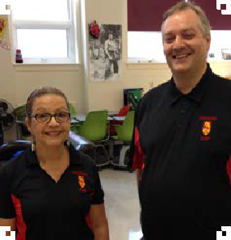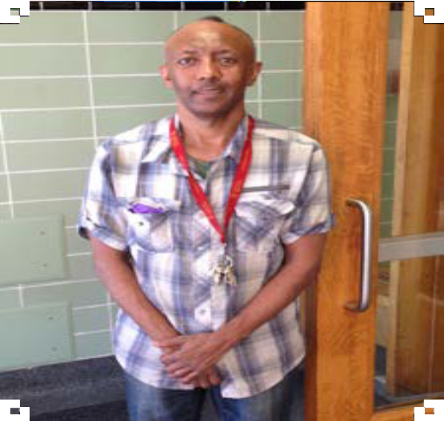Published by the Local 474 Membership October 2017
Local 474 Members
5
Union Representation 780-447-5858 Monday to Friday 8:00 am to 4:30 pm
October 2017

CUPE 474 Retirement Banquet
October 28, 2017
Chateau Louis 11727 Kingsway Avenue

Cocktail: 5:30 pm Dinner: 6:00 pm
Please join us as we honour our members who will be celebrating their retirement

Remy Abuan Jovino Inostroza
Francisco Acevedo Monica Inostroza
Jose Buenaventura Marianna Karczynski
Arturo Cabanding Pol Magnaye
Randy Canafranca Nancy Martinez
Pauline Cardinal Robert Nanad
Hassane Chawa Phung Nguyen
Randy Coombes David Oldham
Clarence Crowley Orlando Reyes
Felix De Santos Wlodek Rozwadowski
Charlotte Detta Donna Shah
Sandra Dietz Shelley Shonert
Halina Dushynski Melchor Somera
Sharon Enns Stephanie Spencer
Flora Glico Norm Stienke
Perla Hernandez Hoang Tran
Patrick Howden Hermes Yu
Tickets available from your Executive Members or the Union Office for $25.00 per person.

